Global Cosmetics Regulation Conference – London
Registration Form
- Company Information:
Company name:
Company address:

- Delegate Information:
Name | Job Title | Tel. | Mobile Number | Email

- Registration fee
☐ €199 (Early Bird, before April 10)
☐ €299 (Standard Price)

- Payment method
☐ Bank transfer ☐ Credit card/ PayPal

Bank Transfer (Invoice can be issued by contacting Ms. Julie Harrington (julie@cirs-reach.com).
Beneficiary Name | CIRS Ltd
Bank Name | Bank of Ireland
Bank Address | Wilton, Cork, Republic of Ireland
Sort Code | 902805
Account # | 90404884
BIC/Swift | BOFIIE2D
IBAN | IE15 BOFI 9028 0590 4048 84

Credit card/ Paypal (Scan the QR code for payment)
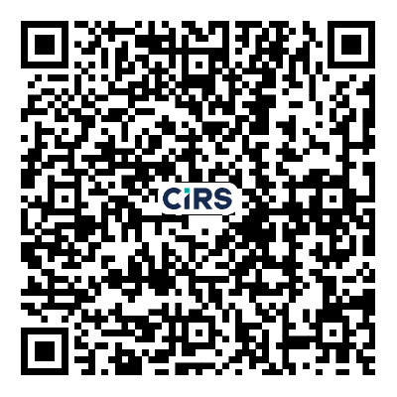
- If you have any questions or topics of interest, please comment below:

Please fill in this registration form and return to Ms. Julie Harrington at julie@cirs-reach.com.

Contact:
Dublin office: Ms. Julie Harrington
T: +353 (0)1 477 3710 (GMT, 9:00-17:30)

